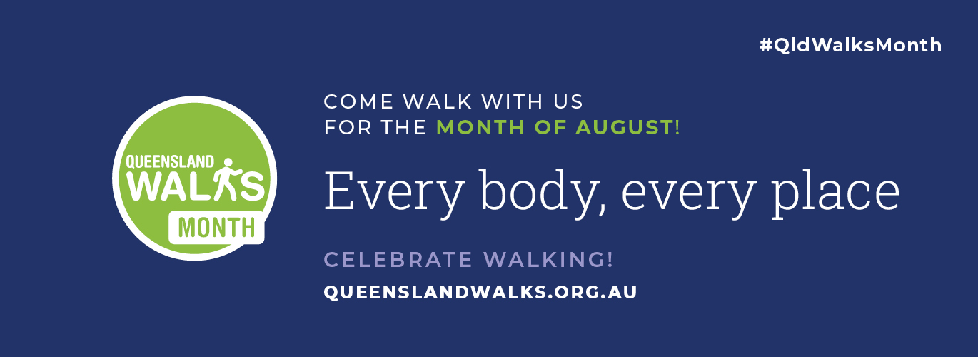

QUEENSLAND WALKS MONTH MEDIA RELEASE TEMPLATE FOR COMMUNITY MEMBERS

[IF YOU WOULD LIKE TO SHARE YOUR WALKING STORY WITH LOCAL MEDIA, PLEASE INCLUDE YOUR DETAILS AND FORWARD THIS MEDIA ALERT TO YOUR LOCAL NEWSPAPER, RADIO OR TELEVISION STATION.]

QUEENSLANDERS BECOME COMMUNITY WALKING CORRESPONDENTS AND JOIN LOCAL REPS ON PATHS FOR QUEENSLAND WALKS MONTH, AUGUST 2022

Everyone who loves a walk, run, roll or stroll is being encouraged to share their walking journeys with local government representatives and the community during Queensland Walks Month to help celebrate walking and improve local walking environments.

Queensland Walks Month, is a free community celebration of walking in Queensland starting 1 August. This year Queensland Walks is inviting Queenslanders to become local ‘Community Walking Correspondents’ and get involved in the annual Queensland Walks Month.

Queensland Walks has been asking for Expressions of Interest from ‘Community Walking Correspondents’ who are Queenslanders willing to share their story about walking in their local neighbourhood or region. Community Walking Correspondents will share their favourite walks during August, and are encouraged to invite their local councillors and state members for a walk to talk about their neighbourhoods and how walking can be improved.

Queensland Walks Executive Officer, Anna Campbell, said Queensland Walks Month celebrates the places and people who walk as part of their every day, and shines a spotlight on why walking provides enormous physical and mental health benefits to Queenslanders.

“We’ve been so excited to see Queenslanders register or recommended to become a community voice for walking in their region! Some local representatives like our Councillors or State MPs have been suggesting some excellent candidates to become a walking correspondent. We’ve had walking correspondents from Cairns, Townsville, and from the South East Queensland, but we’re on the hunt for a correspondent from western and central Queensland who walks, runs, rolls or strolls!

“Walking is the most popular form of recreational activity in Queensland. Queenslanders have always appreciated a good walk and the pandemic prompted renewed interest in walking, for transport, for health and for the environment. People use walking as a free and fun way to stay active with their friends and families and support their physical and mental wellbeing. Residents are noticing their places for walking more, and are asking more from local authorities to prioritise walking infrastructure like footpaths and safe crossings,” Anna said.

“Walk Month promotes the value of walking for the health and wellbeing of Queenslanders and recognises the importance of making walking safe and accessible for all ages and abilities in local neighbourhoods. We will be hosting walks and joining walking activities across Queensland in August. If you have a walk, we’d love to know about it!” says Anna.

“We encourage those who walk alone, in groups or to work, to school or for social or health reasons, and everyone who appreciates the benefits of a good walk, to share their local walking experiences on social media by tagging Queensland Walks and using the hashtag #QldWalksMonth.

“By bringing the walking community together we can improve the conditions and profile of walking in Queensland, identify the value and importance of walking and create more walkable places which will mean more Queenslanders walking more!”

People can share their photos and walking stories via Queensland Walks socials, or find out more information they can visit the Queensland Walks website queenslandwalks.org.au
Queensland Walks Month is hosted by community advocacy group Queensland Walks who aim to improve the health of Queenslanders by encouraging walking every day and promoting better walking environments.
Queensland Walks Month is supported by the Queensland Government, Queensland Walks, 10,000 Steps, Bushwalking Queensland and Heart Foundation Walking.
To find our more information about Queensland Walks Month:
- Queensland Walks Month website https://queenslandwalks.org.au/walkmonth2022/
- Queensland Walks Month promotional resources: https://queenslandwalks.org.au/walk-month-2022/promotional-resources/
- Queensland Walks Month Community Walking Correspondents https://queenslandwalks.org.au/communitywalker/

To help improve the conditions of walking in Queensland:
- Conduct a Walk My Street Checklist using your smart phone or download a copy.
- Follow Queensland Walks on socials or become a member.
- Improve the maintenance of footpaths using Snap Send Solve, the free app that notifies local authorities of any issue that may need addressing.

MEDIA ARE INVITED TO TALK TO A LOCAL WALKER:
Contact Name:
Email:
Phone Number:
Details of your walk: please include Date / Time / Location and confirm that everyone in your walk has provided permission to be photographed or interviewed by the media.

